Online School Portal
https://students.ashworthcollege.edu/dashboard
Username: Carriegilles@ymail.com
Password: 133Pinson

Sign in
Click on Spanish 2: Part 1
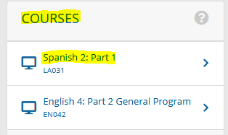

Click on Assessments
- Assignments
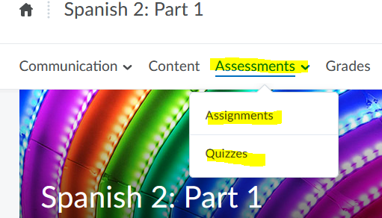

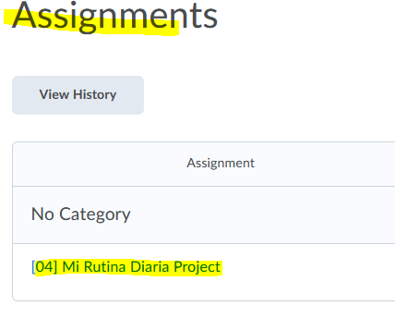

For all information needed on this Essay, it can be found on the portal
Under the Content tab

write an essay, it must be 1-2 paragraphs, 10-15 sentences total. Be sure to use at least 3 of the 4 verb structures you have learned so far—reflexive verbs, present progressive verbs, present tense or preterite tense verbs.
Be sure to use at least 3 of the 4 verb structures you have learned so far—reflexive verbs, present progressive verbs, present tense or preterite tense verbs.
Remember the following:
* You MUST use vocabulary from the course and text to show me that you learned and mastered the material from Spanish 2 Part 1. Make sure you address all the points the teacher suggests you cover that are listed above.
* Watch your grammar and verb forms in your sentences.
* Each sentence must have at least a subject and verb. Remember to properly conjugate your verb and that subjects and verbs must agree, as well as nouns, adjectives and articles.
* Finally, it must be completely done in complete sentences in Spanish. Accent marks, tildes, and any upside down question marks or exclamation points also count towards your score.

1. Requirements:
Part A: Tell about the information listed above in each of the bullet points.
Objective: While on a mission to Perú with your youth group, you are asked by one of your hosts, who teaches high school, to come and speak to some of her classes. She would like her students to know what a typical day is like for the average American high school student. She wants to know the following:
• when you wake up;
• how you get ready for school;
• how and when you get to school;
• what courses you take;
• when and what meals you eat;
• activities after school;
• when you return home and what you do there;
• your nightly routine;
• when you normally go to bed.

